Chapter 2-[Logic](https://mfleck.cs.illinois.edu/building-blocks/version-1.3/logic.pdf)

Monday, December 26, 2022

3:20 PM

***Logik:***



is shorthand for "and" (equivalent to the AND Operator)

A ***Proposition*** is a statement which is true or false (but never both!). (It can’t be a question. It also can’t contain variables, and a claim needs to be stated in the proposition) *Not as useful in Proofing.*



Is shorthand for "or" (equivalent to the OR Operator)



Is shorthand for "Not p" (equivalent to the NOT Operator)



Is shorthand for "If p then q"



Is shorthand for "if p then q, and the converse is also true"



Is shorthand for the contrapositive of if p then q, and **is** equivalent to if p then q.

Ordering in Mathematical Shorthand: apply the “not” operators first, then the “and” and “or”. Then you take the results and do the implication operations. (similar to high school algebra rules)

Logical Equivalence:



De Morgan's Law:

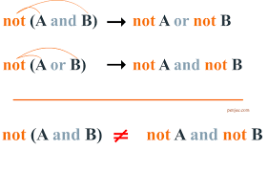

T and F are special constant propositions with no variables that are, respectively, always true and always false.



The equal operator **=** can only be applied to **objects** such as numbers. When comparing **logical expressions** that return true/false values, you must use **≡**.

Distributive Rules:

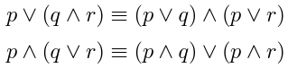

(you can distribute either operator over the other)

The Conditional to OR/AND Rule:





(Recall this is true because in p -> q, when p is false, the statement is always true, and when p is true, the statement is true only when q is true)

A ***Predicate*** is a statement that becomes true or false if you substitute in values for its variables.

Quantifiers:

There are only 3, and the first 2 are the most common:



*For All* (universal quantifier),



*There Exists* (existential quantifier),



*There exists a unique* … (unique existence, used when there is only 1 object that matches some requirements)

Examples:







“Such that” is sometimes abbreviated “s.t.”

*(Mathematicians are lazy)*

Contrapositives also exists for statements with quantifiers.

For example:



And its contrapositive:



The quantifier stays the same: only transform the if/then part.

Representing 2D points:

Either refer to 2 single variables and pair them up, like so:



And refer to them as a pair later on, or

Treat the pair as a single variable, like so:



Or be even more abstract:



(and then later define what "p" and "the unit circle" means)

**Predicate Logic "De Morgan's Laws":**



“for all x in A, P(x)” is false when (is equivalent) to "there is some value x in A such that P(x) is false"



“there exists x in A such that P(x) is true" is false when (is equivalent to) "for all x in A, P(x) is false"

(P(x) is a statement like x > 0 or whatever, and A can be some set like real numbers or whatever)

Example:



Its **negation** is:

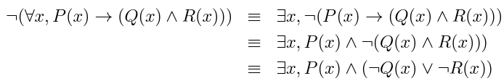

**Bounding and Scope:**

A quantifier **binds** to a variable, but if a variable hasn’t been bound by a quantifier, (or otherwise given a value or a set of replacement values), it is called a **Free Variable.**

**Free variables** don’t have a defined truth value, so they **cannot** be a step in a proof.

The “bound” variable in a quantification is only defined for a limited time, called the **Scope** of the binding.

Qualifiers define the scope of the variable. For example, the **i** in



is only defined while you are still inside the summation.